New Riemann’s Functional Equation for Odd Numbers

Shaimaa said soltan1

1 Computer Engineer, Toronto, Canada

Correspondence: Shaimaa Soltan, 3050 Constitution Blvd, Mississauga, ON., L4Y 3X1, Canada. Tel: 1-647-801-6063 E-mail: shaimaasultan@hotmail.com

---------------------------------------------------------------------------------------------------------------------------------

**Suggested Reviewers** (Optional)

Please suggest 3-5 reviewers for this article. We may select reviewers from the list below in case we have no appropriate reviewers for this topic.

|  |  |
| --- | --- |
| Name: | E-mail: |
| Affiliation: | |

|  |  |
| --- | --- |
| Name: | E-mail: |
| Affiliation: | |

|  |  |
| --- | --- |
| Name: | E-mail: |
| Affiliation: | |

|  |  |
| --- | --- |
| Name: | E-mail: |
| Affiliation: | |

|  |  |
| --- | --- |
| Name: | E-mail: |
| Affiliation: | |

New Riemann’s Functional Equation for Odd Numbers

**Abstract**

This paper introduces a new functional form for Zeta function to proof Zeta function will converge to Zero at S = S+ 0.5 for any odd number using this new derived formula from Riemann’s functional equation. By breaking down gamma function into Euler formula.

**Keywords:** zeta function, Riemann hypothesis, complex plane, none-trivial zeros, critical strip

**1. Introduction**

Riemann's functional equation

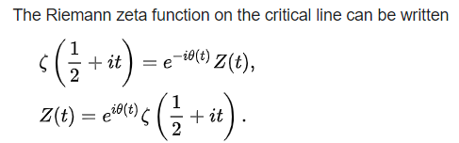

We can generalize this formula in a conceptual form.

$$Riemann^{'}sfunctional equation= {Euler}^{'}s formula * trigonometric formula*some constant$$

Where this constant is the evaluation result for the rest of the terms in the Zeta functional formula regardless of its value.

Therefore, we only need to study these two terms, [ ${Euler}^{'}s formula * trigonometric formula$], and their effect on the result of any complex number.

🡺(1)

And based on Stirling’s formula we can replace gamma function with Euler formula as Stirling’s formula states that there is relation between gamma function and factorials in general.

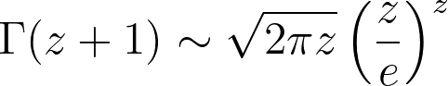



where?

�(�)=∑�=0∞((�+�+12)ln⁡(1+1�+�)−1).

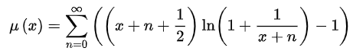

So, we can replace gamma function in the zeta functional form by Euler’s formula multiply some constant.



$$ζ\left(S\right)=2^{S}* π^{S-1}*\sin\left(\frac{π*S}{2}\right)*Г\left(1-S\right)*ζ\left(1-S\right)$$

At S = S +1/2

$$ζ\left(S+\frac{1}{2}\right)=2^{S+\frac{1}{2}}* π^{S-\frac{1}{2}}*\sin\left(\frac{π}{2}*\left(S+\frac{1}{2}\right)\right)*Г\left(\frac{1}{2}-S\right)*ζ\left(\frac{1}{2}-S\right)(2)$$

$$Г\left(\frac{1}{2}-S\right)\sim K*\sqrt{2}*e^{i*\left(\frac{1}{2}-S\right)*π}(3)$$

$$ζ\left(S+\frac{1}{2}\right)=2^{S+\frac{1}{2}}* π^{S-\frac{1}{2}}*\sin\left(\frac{π}{2}*\left(S+\frac{1}{2}\right)\right)*K*\sqrt{2}*e^{i*\left(\frac{1}{2}-S\right)*π}*ζ\left(\frac{1}{2}-S\right)$$

$$ζ\left(S+\frac{1}{2}\right)=2^{S+\frac{1}{2}}* π^{S-\frac{1}{2}}*K*\sqrt{2}*\sin\left(\frac{π}{2}*\left(S+\frac{1}{2}\right)\right)*e^{i*\left(\frac{1}{2}-S\right)*π}*ζ\left(\frac{1}{2}-S\right)$$

$$ζ\left(S+\frac{1}{2}\right)=W*\sqrt{2}*\sin\left(\frac{π}{2}*\left(S+\frac{1}{2}\right)\right)*e^{i*\left(\frac{1}{2}-S\right)*π}*ζ\left(\frac{1}{2}-S\right)$$

$$\sqrt{2}*\sin\left(\frac{π}{2}*\left(S+\frac{1}{2}\right)\right)*e^{i*\left(\frac{1}{2}-S\right)*π}=\left\{\begin{aligned}i ;∀ x even natural number \\ -i ; ∀ x odd natural number \end{aligned}\right.(4)$$

And because

$$f(S)= \sin\left(\frac{π}{2}*\left(S+\frac{1}{2}\right)+\frac{π}{4}\right)*e^{i*\left(\frac{1}{2}-S\right)*π}=0 for any odd natrual Number$$

$$=\sin\left(\frac{π}{2}*\left(S+\frac{1}{2}\right)+\frac{π}{4}\right)*\cos\left(\left(\frac{1}{2}-S\right)*π\right)+i* \sin\left(\frac{π}{2}*\left(S+\frac{1}{2}\right)+\frac{π}{4}\right)* \sin\left(\left(\frac{1}{2}-S\right)* π\right)=0$$

Therefore. For any odd natural number S at S = S +1/2 zeta function = 0

$$ζ\left(S+\frac{1}{2}\right)=2^{S+\frac{1}{2}}* π^{S-\frac{1}{2}}*\sin\left(\frac{π}{2}*\left(S+\frac{1}{2}\right)+\frac{π}{4}\right)*K*\sqrt{2}*e^{i*\left(\frac{1}{2}-S\right)*π}*ζ\left(\frac{1}{2}-S\right)=0(5)$$

$$ζ\left(S+\frac{1}{2}\right)=2^{S+1}* π^{S-\frac{1}{2}} *K*f\left(S\right)*ζ\left(\frac{1}{2}-S\right)=0$$

Therefore, also we can write Zeta function at S = S +1/2 as

$$ζ\left(S+\frac{1}{2}\right)=2^{S+1}* π^{S-\frac{1}{2}}*K*\sin\left(\frac{π}{2}*\left(S+\frac{1}{2}\right)+\frac{π}{4}\right)*e^{i*\left(\frac{1}{2}-S\right)*π}*ζ\left(\frac{1}{2}-S\right)(6)$$

As Term ${(Euler}^{'}s formula * trigonometric formula)=0$

$$Therefor for any odd natural number at S=S+\frac{1}{2} ;Zeta functional form=0$$

And because $\sin\left(x+y \right)=sin\left(x\right)*cos\left(x\right)+sin\left(y\right)\cos\left(x\right)$

$$\sin\left(\frac{π}{2}*\left(S+\frac{1}{2}\right)+\frac{π}{4}\right) can be simplified to\sin\left(\frac{π*S}{2}\right) which give complex numbers for S=odd number=b*i$$

Based on the next analysis we will show that these two terms only; restrict the result of the Zeta function in a specific matter

1 - Multiplying [ ${Euler}^{'}s formula * trigonometric formula]$ by some constant will result in complex numbers on a line y =x with slope =1 or -1. Regardless of how the rest of the terms in the zeta function will evaluate to.

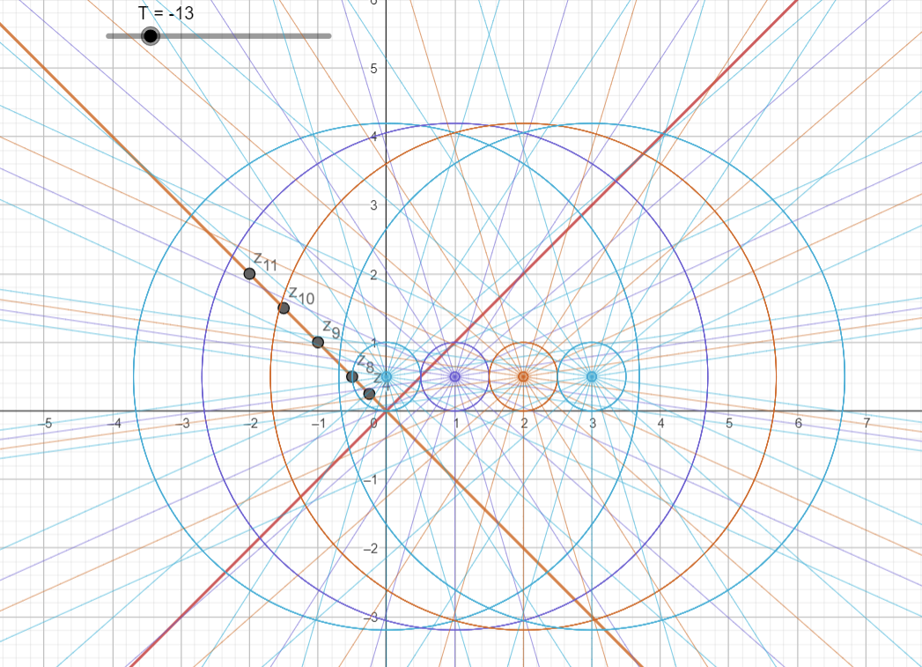

2- Multiplying [ ${Euler}^{'}s formula*Sin\left(x\right)]$ is shifting our complex plane origin to the point (0,0.5) instead of (0.0) and the complex plane unit circle will be with radius =0.5.



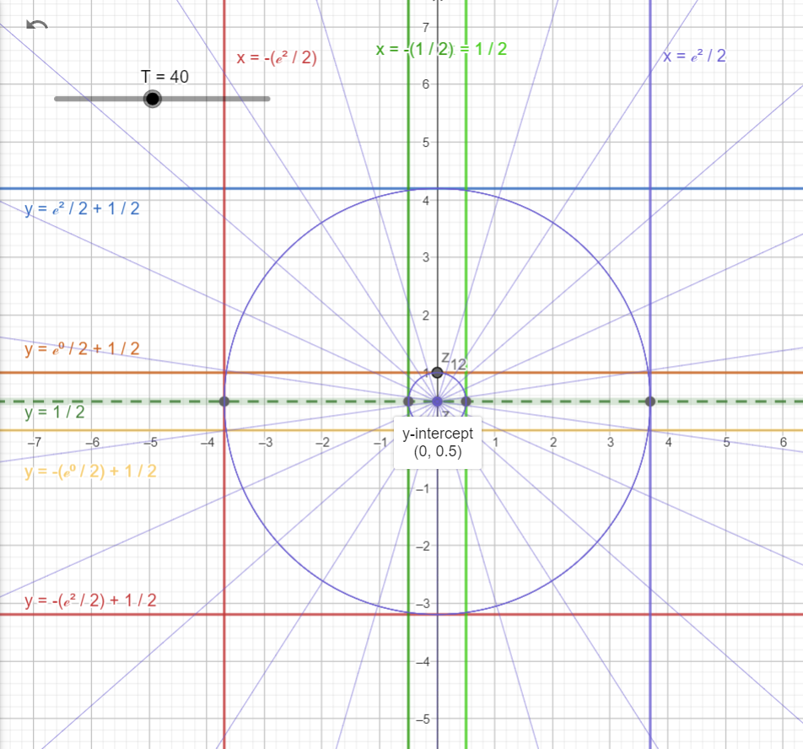

3- Multiplying [ ${Euler}^{'}s formula*Cos\left(x\right)]$ is shifting our complex plane origin to the point (0.5,0) instead of (0.0) and the complex plane unit circle will be with radius =0.5.

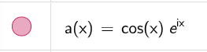

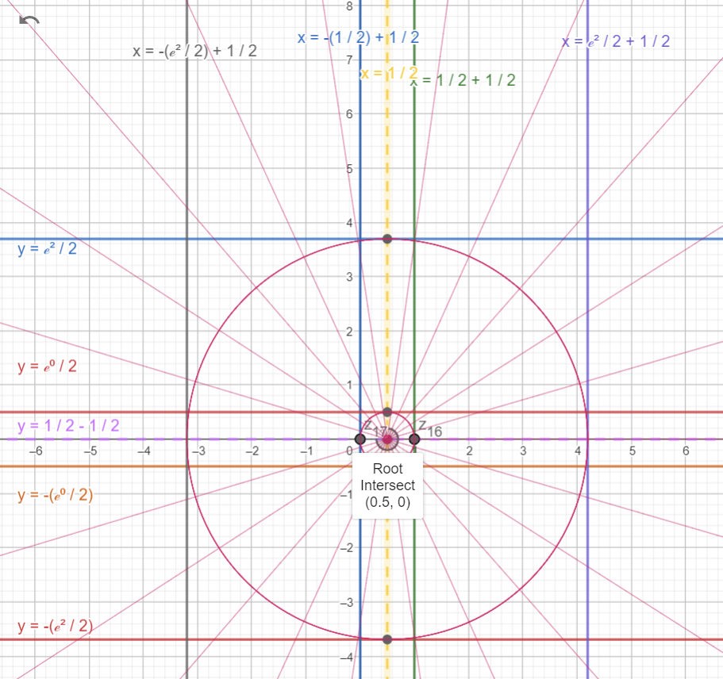

4- $using e^{i*x }=\cos\left(x\right)+i*sin⁡(x)$ will give us more accurate exact value for 0.5 for any neutral number x

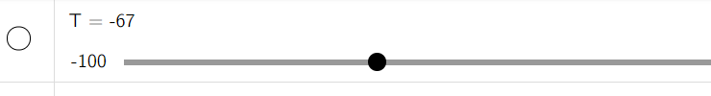

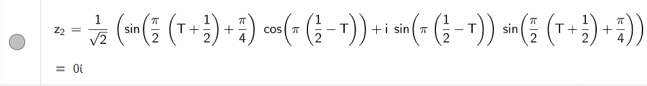



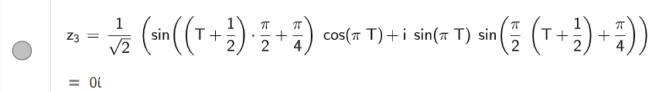

5- when using x = x+1/2 with $Sin\left(x*\frac{π}{2}\right)$ and $e^{i*x*\frac{π}{2} }$

$Sin\left((x+\frac{1}{2})*\frac{π}{2}\right)*e^{i*\left(x+\frac{1}{2}\right)*\frac{π}{2}}=\sin\left(\left(x+0.5\right)*\frac{π}{2}\right)*\cos\left(\left(x+0.5\right)*\frac{π}{2}\right)+i*\sin^{2}\left(\left(x+0.5\right)*\frac{π}{2}\right)=±0.5+b*i$

6- $\sin\left(\left(x+\frac{1}{2}\right)*\frac{π}{2}\right)*\cos\left(\left(x+\frac{1}{2}\right)*\frac{π}{2}\right)*e^{i*\left(X+\frac{1}{2}\right)*\frac{π}{2}}=\frac{1}{2}*e^{\frac{iπ}{4}} at x=0$

7- 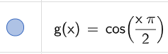 Zero out all odd natural numbers

8-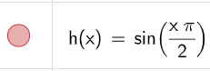Zero out all even natural numbers

9-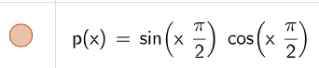Zero out all Natural numbers and have only value = ½ at x = x+1/2

10- 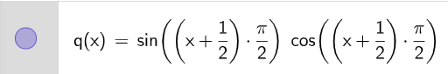 ½ = at any natural number even x and = -1/2 at each odd natural number

11- 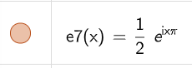 multiplying $e^{\begin{aligned}i*x*π \\ \end{aligned}}$ by ½ scale complex number unit circle to half its size therefore this function Zeros will be at ±0.5 and the complex plane imaginary unit will be = i/2

12- 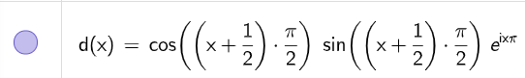 multiplying by $e^{\begin{aligned}i*x*π \\ \end{aligned}}$

Is Like limiting our range from 0 to +∞ instead of original range from -∞ to +∞

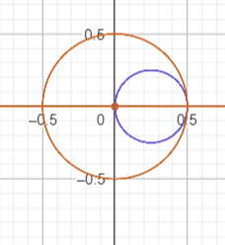

13 - 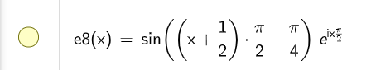these are the terms in Zeta function

= 0 for any X odd natural number and = 1 for any X even number

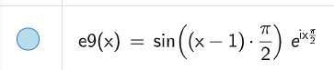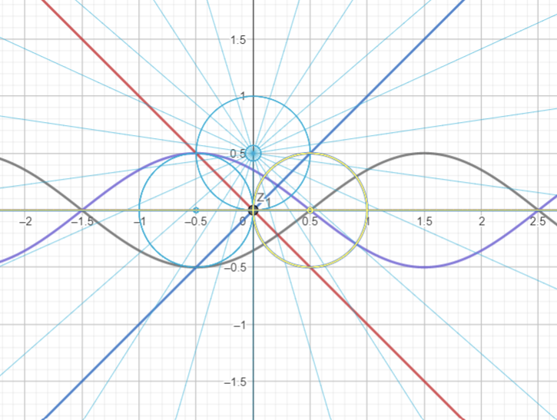

Therefore if

$$f\left(x\right)= \sin\left(x\right)*e^{i*x }$$

$$f\left(x\right)=\sin\left(x\right)*\cos\left(x\right)+i*\sin^{2}{(x)}$$

$$for any nutral number x$$

$$f\left(x\right)= \left\{\begin{aligned}\sin\left(x* π\right)*\cos\left(x* π\right)+i*\sin^{2}\left(x* π\right)=0 \\ \sin\left(2*x* π\right)*\cos\left(2*x* π\right)+i*\sin^{2}\left(2*x* π\right)=0 \\ \sin\left(x*\frac{π}{2}\right)*\cos\left(x*\frac{π}{2}\right)+i*\sin^{2}\left(x*\frac{π}{2}\right)=0 ;for any even x \\ \sin\left(x*\frac{π}{2}\right)*\cos\left(x*\frac{π}{2}\right)+i*\sin^{2}\left(x*\frac{π}{2}\right)=i ;for any odd x \\ \sin\left(\left(x+0.5\right)* π\right)*\cos\left(\left(x+0.5\right)* π\right)+i*\sin^{2}\left(\left(x+0.5\right)* π\right)=i \\ \sin\left(\left(x+0.5\right)*\frac{π}{2}\right)*\cos\left(\left(x+0.5\right)*\frac{π}{2}\right)+i*\sin^{2}\left(\left(x+0.5\right)*\frac{π}{2}\right)=±0.5+b*i \end{aligned}(7)\right.$$

And if

$$f\left(x\right)= \cos\left(x\right)*e^{i*x }$$

$$f\left(x\right)=\cos^{2}{(x)}+\sin\left(x\right)*\cos\left(x\right)*i$$

$$for any nutral number x$$

$$f\left(x\right)= \left\{\begin{aligned}\cos^{2}\left(x* π\right)+\sin\left(x* π\right)*\cos\left(x* π\right)*i=1 \\ \cos^{2}\left(2*x* π\right)+\sin\left(2*x* π\right)*\cos\left(2*x* π\right)*i=1 \\ \cos^{2}\left(x*\frac{π}{2}\right)+\sin\left(x*\frac{π}{2}\right)*\cos\left(x*\frac{π}{2}\right)*i=1 ;for any even x \\ \cos^{2}\left(x*\frac{π}{2}\right)+\sin\left(x*\frac{π}{2}\right)*\cos\left(x*\frac{π}{2}\right)*i=0 ;for any odd x \\ \cos^{2}\left(\left(x+0.5\right)* π\right)+\sin\left(\left(x+0.5\right)* π\right)*\cos\left(\left(x+0.5\right)* π\right)*i=0 \\ \cos^{2}\left(\left(x+0.5\right)*\frac{π}{2}\right)+\sin\left(\left(x+0.5\right)*\frac{π}{2}\right)*\cos\left(\left(x+0.5\right)*\frac{π}{2}\right)*i=0.5+b*i \end{aligned}(8)\right.$$

Adding any number to f(x) will not going to change the final value of the complex number it will remain carrying this 0.5 along any coming number in the Zeta functional formula represented by Z(S±1).

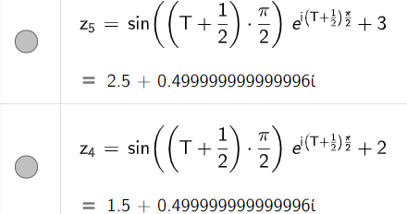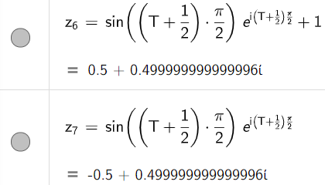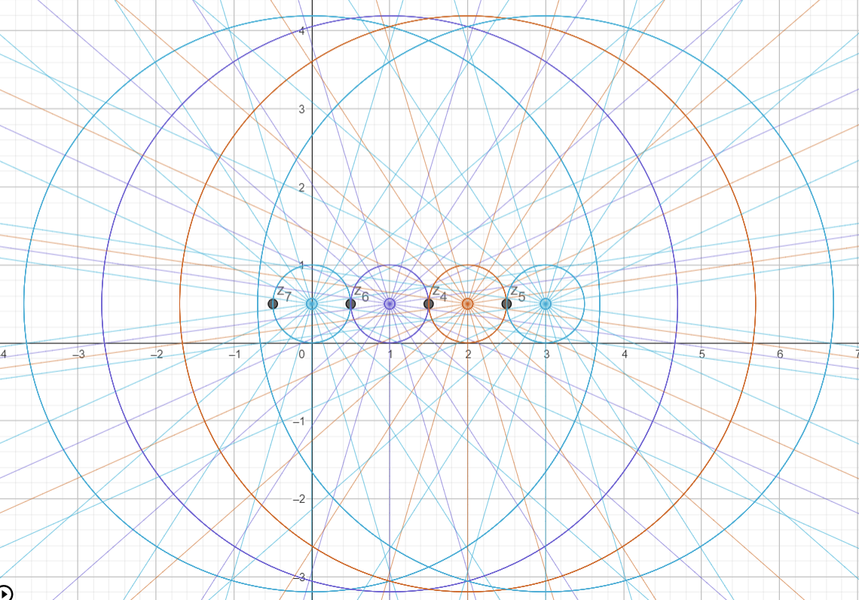

Therefor multiply [ ${Euler}^{'}s formula * trigonometric formula]$ by some constant which will be the value of the rets of terms in Zeta function; result complex numbers on a line y =x with slope =1 or -1. Regardless of the value of the rets of the terms in the zeta function will evaluates to.

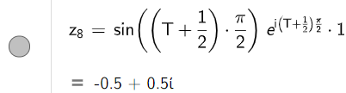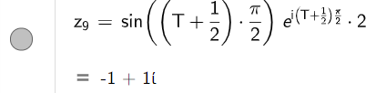

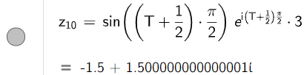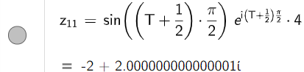

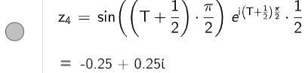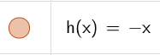

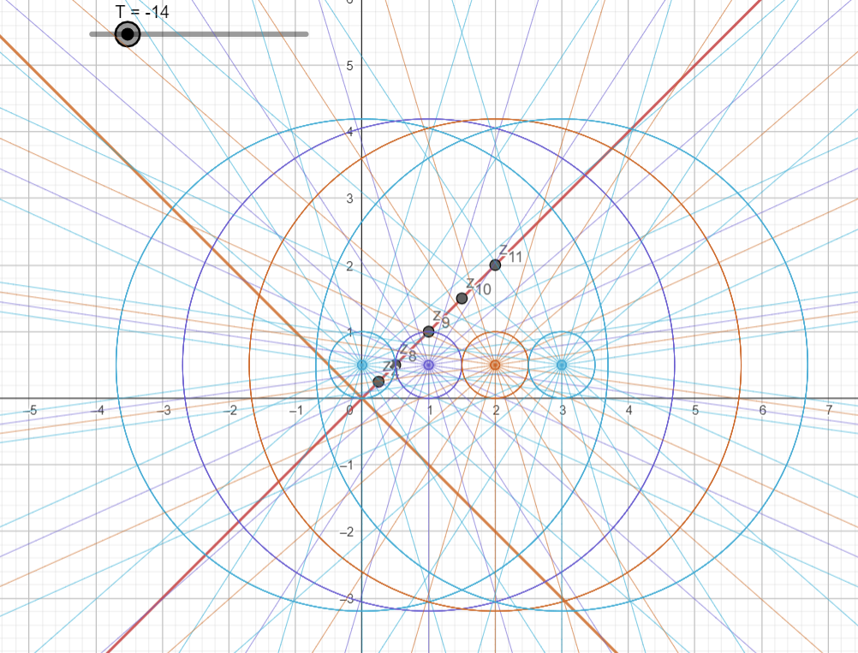

When T is even number all complex numbers will be distributed on the linear relation y = x. and when T odd all complex numbers will be distributed on the linear relation y = -x.



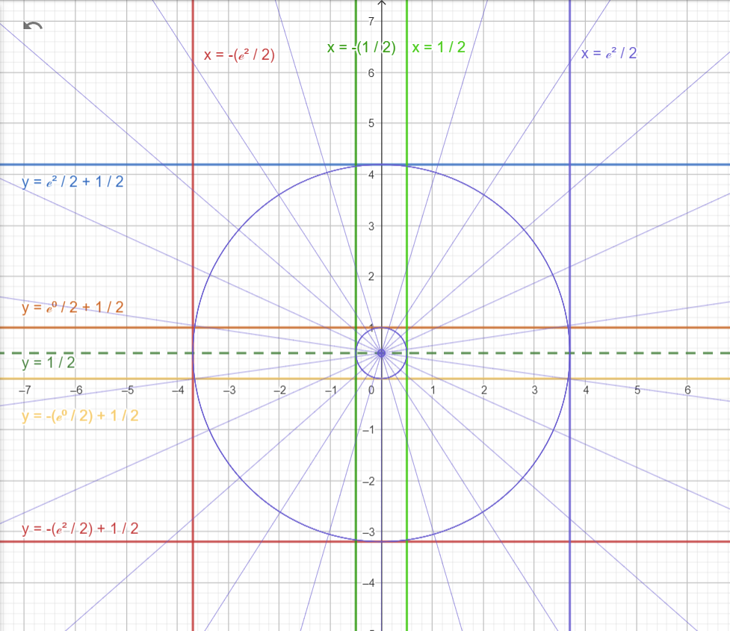



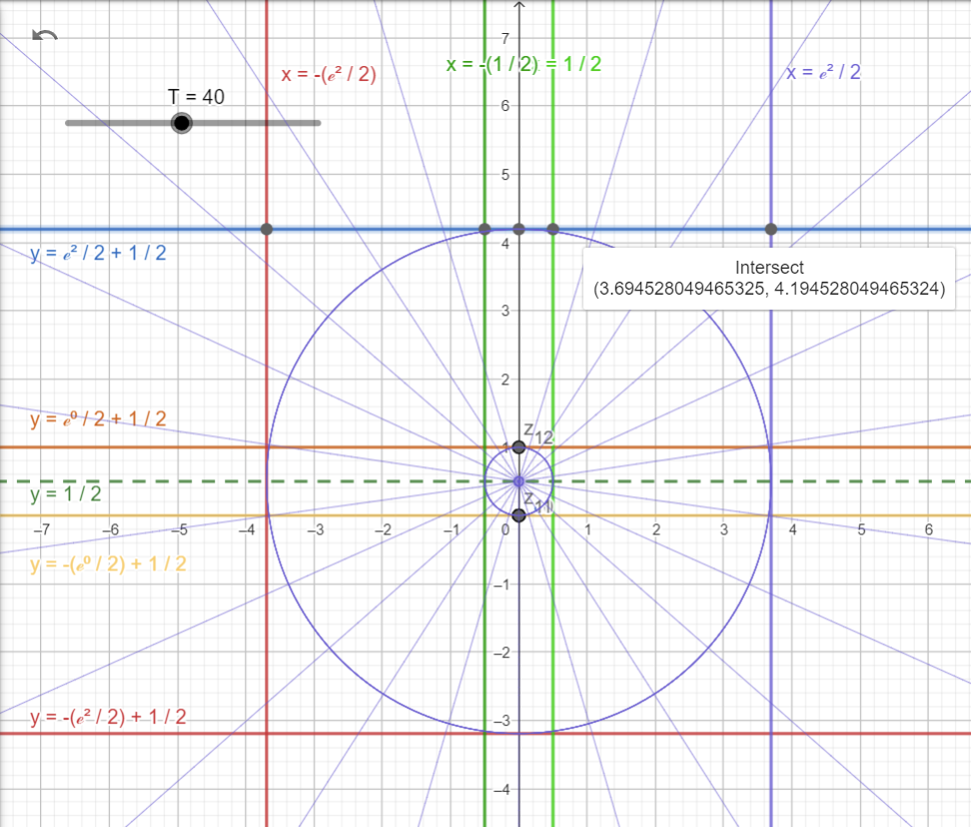



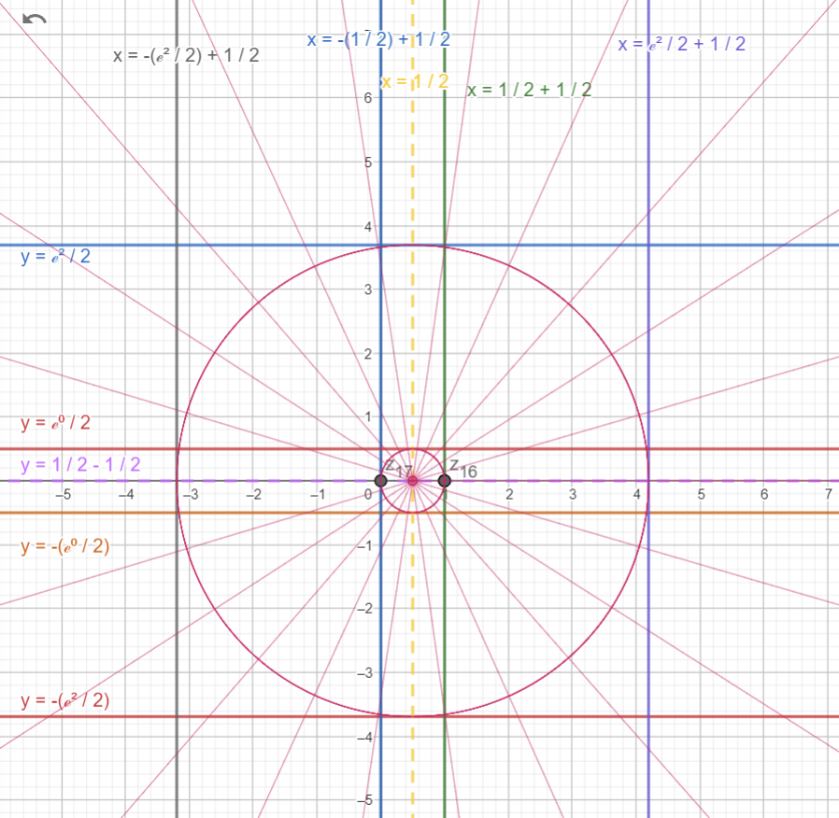



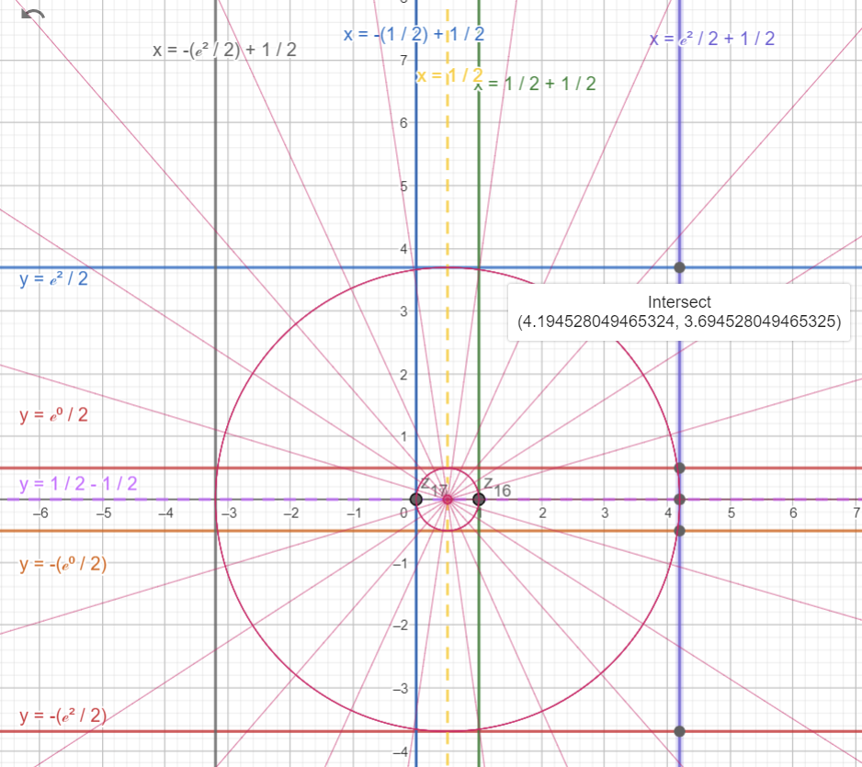

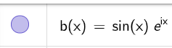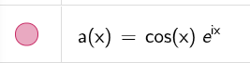

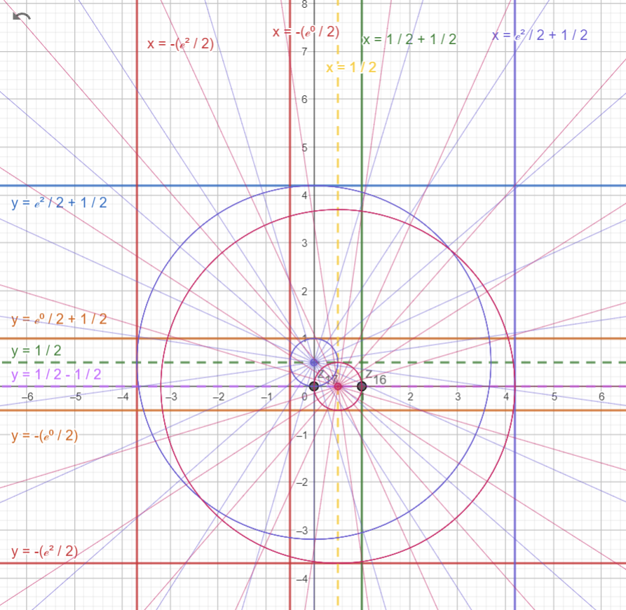



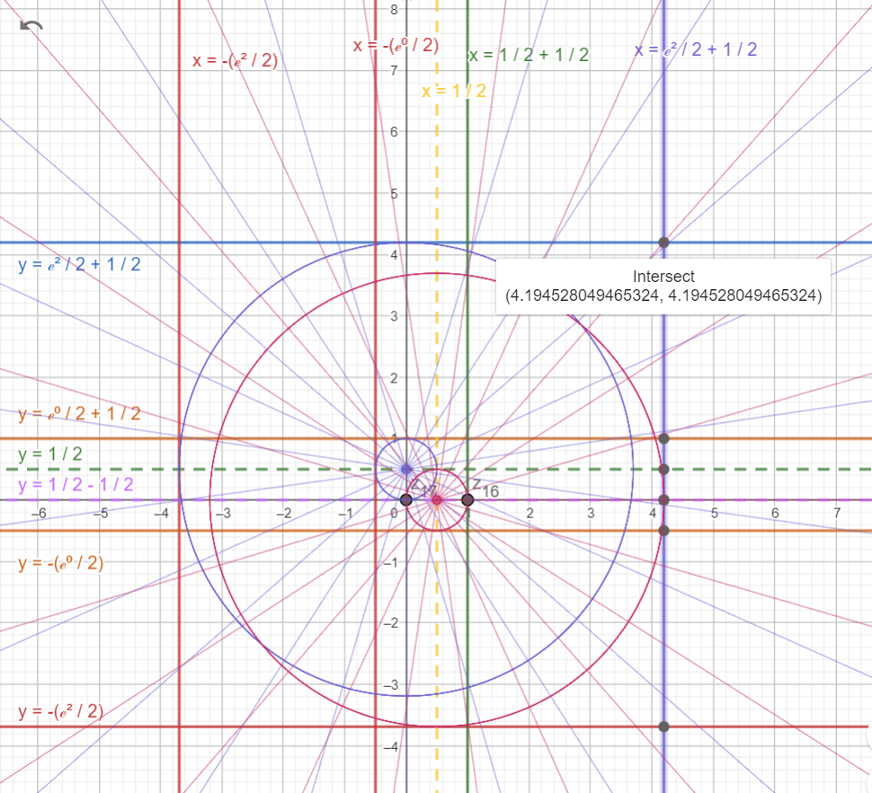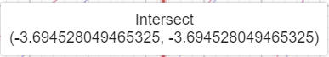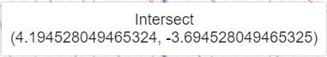



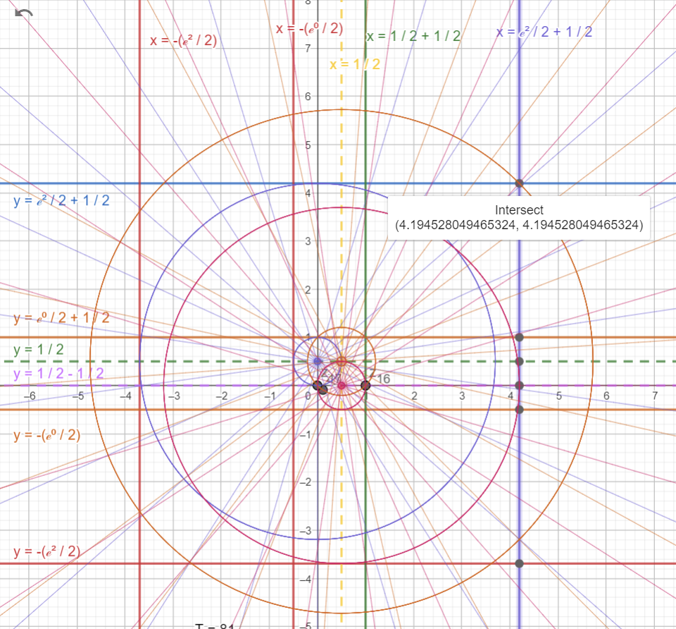

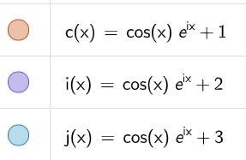

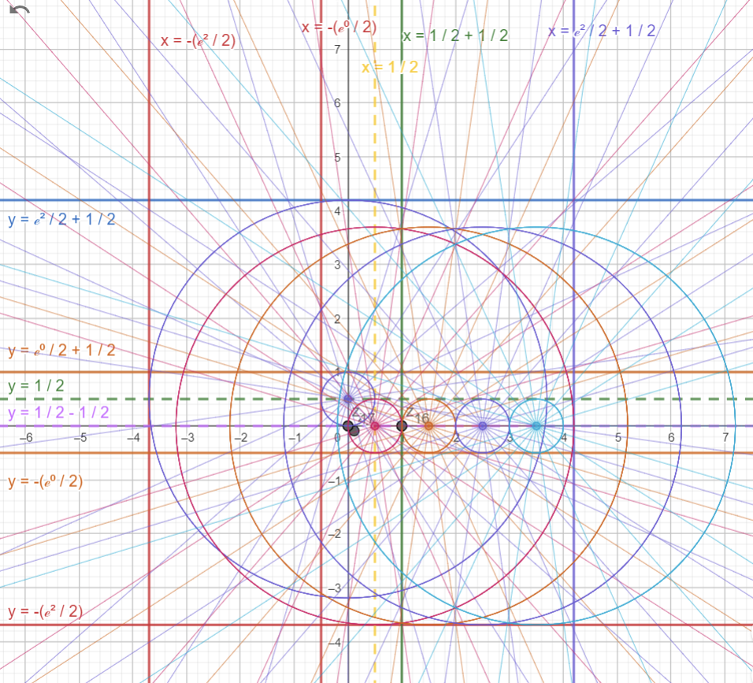

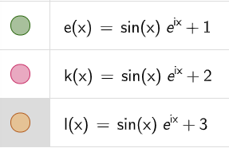

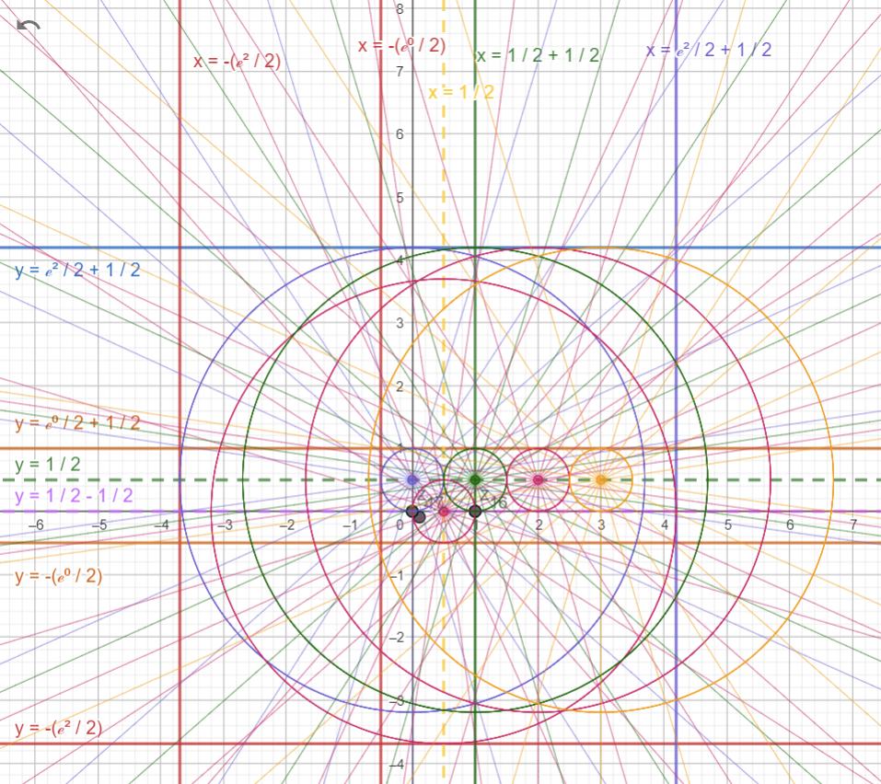

**Conclusion**

This paper we studied zeta functional in theoretical and abstract way then we derived new functional form by breaking down the gamma function in Riemann’s functional equation into Euler formula.

In this new functional Equation Zeta function converges to 0 at S = S +0.5. for any odd natural number.

$$Г\left(\frac{1}{2}-S\right)\sim K*\sqrt{2}*e^{i*\left(\frac{1}{2}-S\right)*π}(3)$$

$$0=ζ\left(S+\frac{1}{2}\right)=2^{S+1}* π^{S-\frac{1}{2}}*K*\sin\left(\frac{π}{2}*\left(S+\frac{1}{2}\right)+\frac{π}{4}\right)*e^{i*\left(\frac{1}{2}-S\right)*π}*ζ\left(\frac{1}{2}-S\right)(6)$$

**References**

[1] Milton Abramowitz and Irene A. Stegun, eds., Handbook of Mathematical Functions, Dover Publications, New York (1972).

[2] A series representation for the Riemann Zeta derived from the Gauss-Kuzmin-Wirsing Operator" (PDF). *Linas.org*. Retrieved 4 January 2017. http://linas.org/math/poch-zeta.pdfrg)

[3] Stefano Isola, On the Spectrum of Farey and Gauss Maps, preprint, undated (2004 or earlier)